**Project Design Phase-I**

**Solution Architecture**

|  |  |
| --- | --- |
| Date | 19 September 2022 |
| Team ID | PNT2022TMID50320 |
| Project Name | Project – Customer care registry |
| Maximum Marks | 4 Marks |

**Solution Architecture:**

**Solution architecture** is the practice of designing, describing, and managing solution engineering to match it with specific business problems. Its goals are to:

* Increase customer satisfaction. One of the primary reasons to offer customer service at all is to improve your customers' happiness.
* Improve net promoter score.
* Reduce customer wait time.
* Reduce cost per contact.
* Channel-specific metrics.

**Example - Solution Architecture Diagram:**

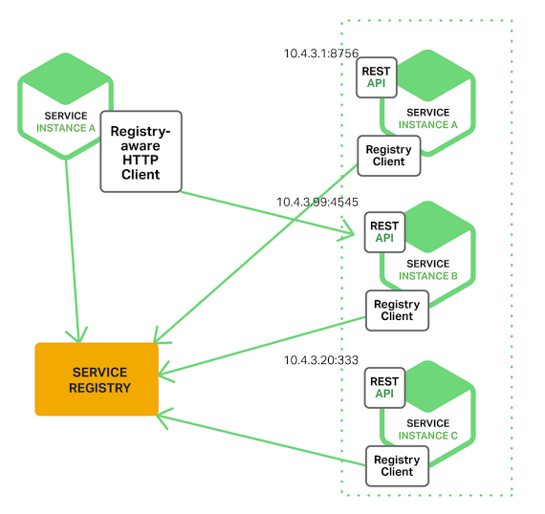

Figure 1: Architecture and data flow of the voice patient diary sample application

**Reference:** [**https://aws.amazon.com/blogs/industries/customer care registry -in-clinical-research-powered-by-ai-on-aws-part-1-architecture-and-design-considerations/**](https://aws.amazon.com/blogs/industries/customer%20care%20registry%20-in-clinical-research-powered-by-ai-on-aws-part-1-architecture-and-design-considerations/)